11.)

(p∨(q ∧ ~p))

~p ∧ ~(~p ∧ q) DeMorgan law

~p ∧ (~~p ∨ ~q) DeMorgan law

~p ∧ (p ∨ ~q) Double Negation law

(~p ∧ p) ∨ (~p ∧ ~q) Distribution law

F ∨ (~p ∧ ~q ) Negation law

(~p ∧ ~q) ∨ F Commutative law

(~p ∧~q) Identity law

(~q ∧~p) Commutative law

(~q ∧~p) = (~q ∧~p)

So proposition i.) is equal to proposition ii.)

12.)

|  |  |  |  |  |  |  |  |
| --- | --- | --- | --- | --- | --- | --- | --- |
| p | q | r | q v p | r v p | (~q v r) | (q v p) ʌ (~q v r) | ((q v p) ʌ (~q v r))-> (r v p) |
| T | T | T | T | T | T | T | T |
| T | T | F | T | T | F | F | T |
| T | F | T | T | T | T | T | T |
| T | F | F | TT | T | T | T | T |
| F | T | T | T | T | T | T | T |
| F | T | F | T | F | F | F | T |
| F | F | T | F | T | T | F | T |
| F | F | F | F | F | T | F | T |

13.)

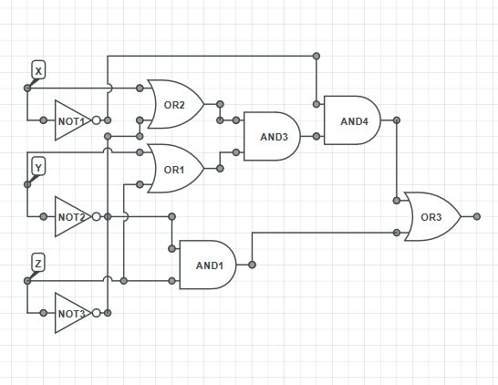

16.)

|  |  |  |  |  |
| --- | --- | --- | --- | --- |
|  | 00 | 01 | 11 | 10 |
| 00 | 0 | 0 | 0 | 0 |
| 01 | 0 | 1 | 1 | 0 |
| 11 | 1 | 1 | 0 | 0 |
| 10 | 0 | 1 | 0 | 0 |

F(x,y,z,w) = xyz’ + x’yw + xz’w

17.)

import java.util.*;  
import java.io.*;  
  
public class Prime{  
  
  
public static void main(String args[])  
{  
 int number = 3; //This is the number that will check if it is prime  
  
 if (isPrime(number))  
 {  
 System.out.println("Number is prime!");  
 }  
 else  
 {  
 System.out.println("Number is not prime!");  
 }  
}  
  
 static boolean isPrime(int X)  
 {  
   
 if (X%2==0) return false;  
 for(int i=3;i*i<=X;i+=2)   
 {  
 if(X%i==0)  
 return false;  
 }  
 return true;  
  
   
 }  
  
}